**SBA-6**

**Cucumber_Jenkins**

Install the necessary pluggins

**Dashboard->Manage Jenkins->Mange Plugins->Available**

Install the below without restarting

**1.Maven Integration**

**2.Cucumber**

**3.Cucumber Trend Report**

**4.Cucumber Report**

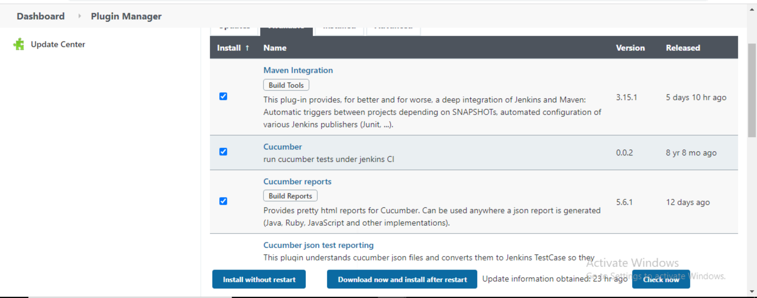

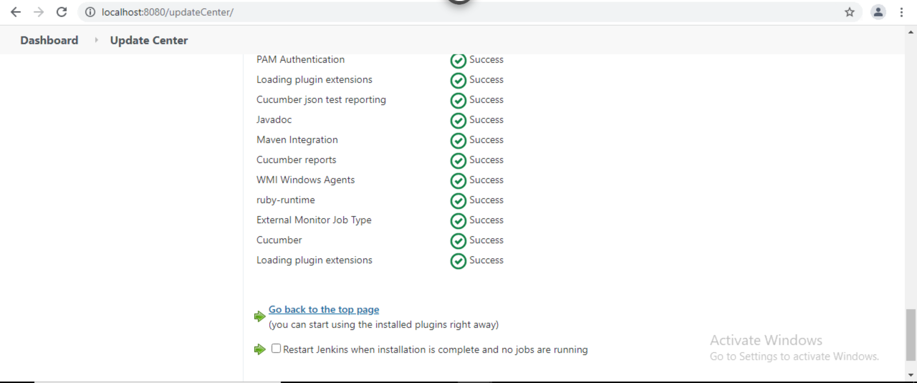

Go back to dashboard and create a New Item

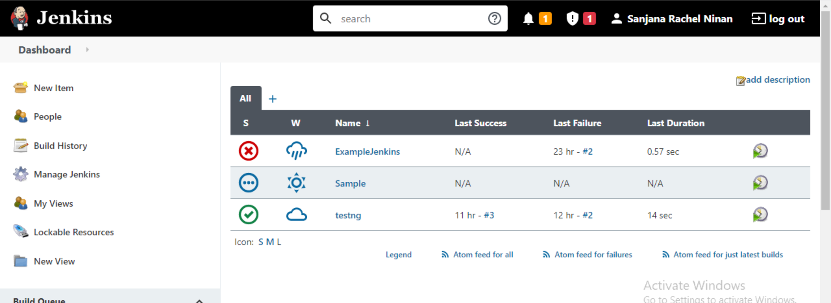

Enter the name of the item

**Maven project -> OK**

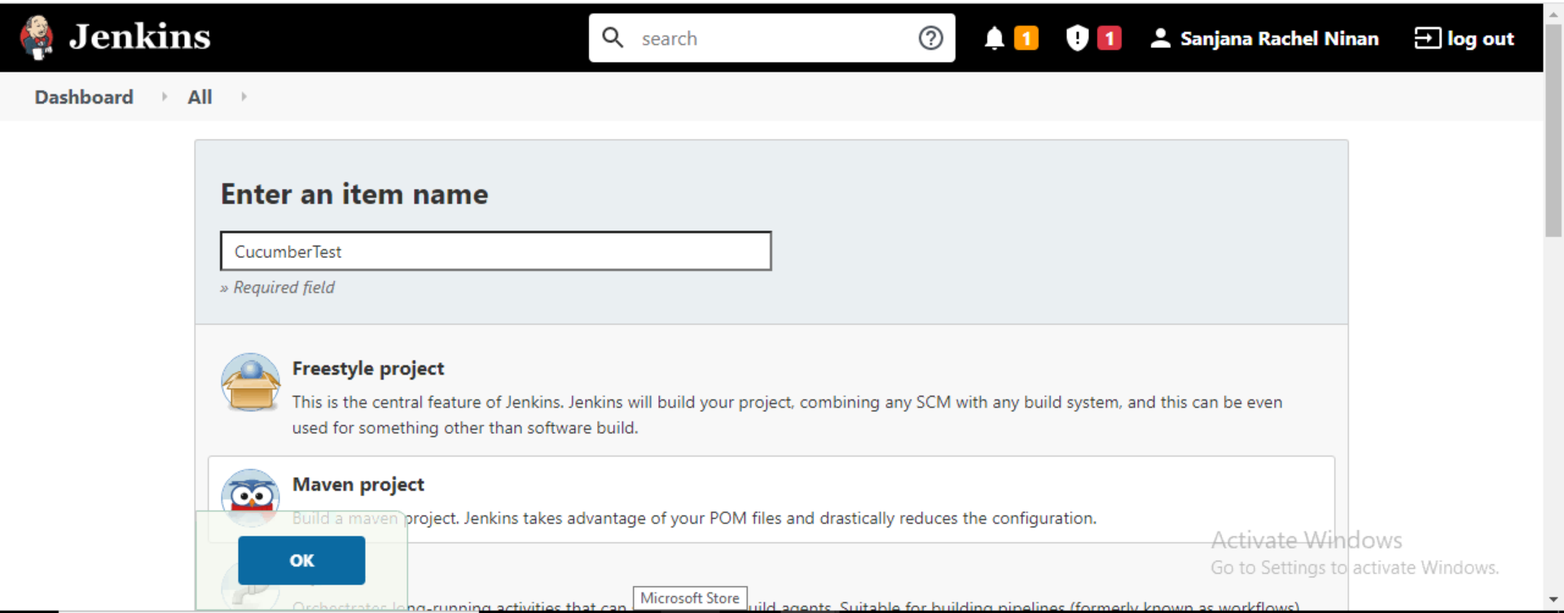

**Go back to Dashboard->Manage Jenkins->Global tool Configuration**

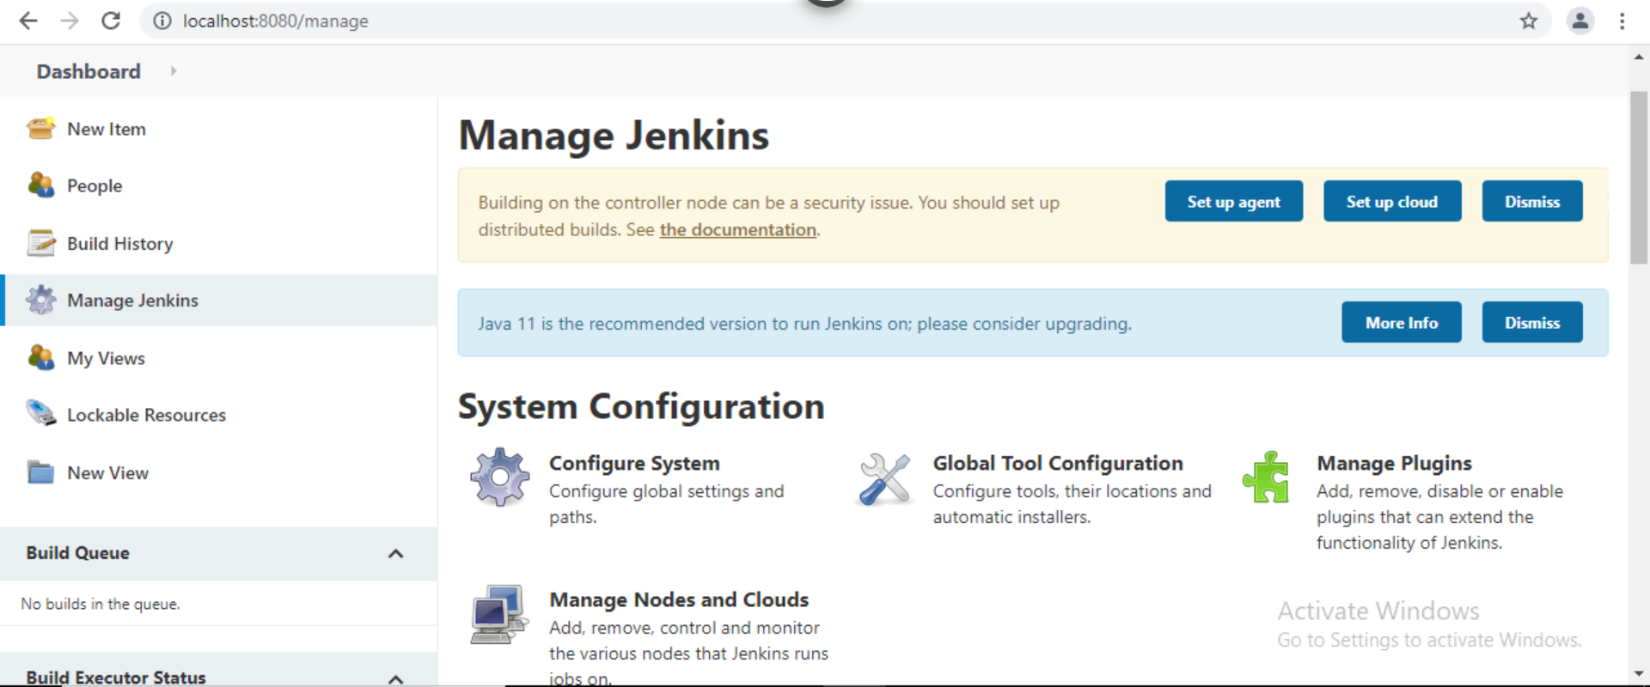

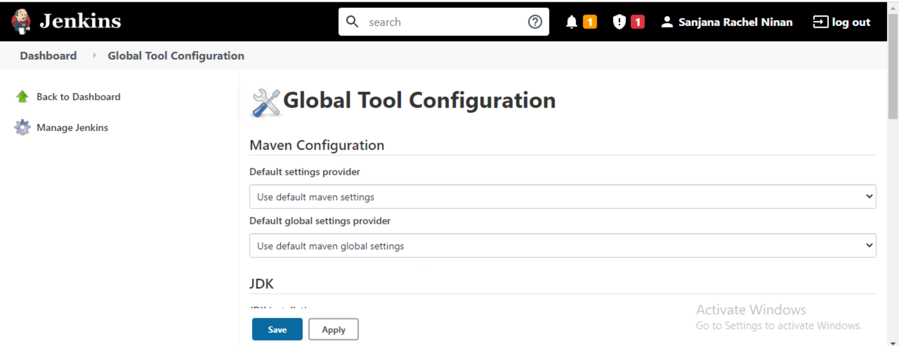

Go to JDK

**Enter the name(JAVA_HOME) -> Under the specified name(JAVA_HOME) enter the path of the jdk file**

If not installed

[**https://www.oracle.com/in/java/technologies/javase/javase8-archive-downloads.html**](https://www.oracle.com/in/java/technologies/javase/javase8-archive-downloads.html)



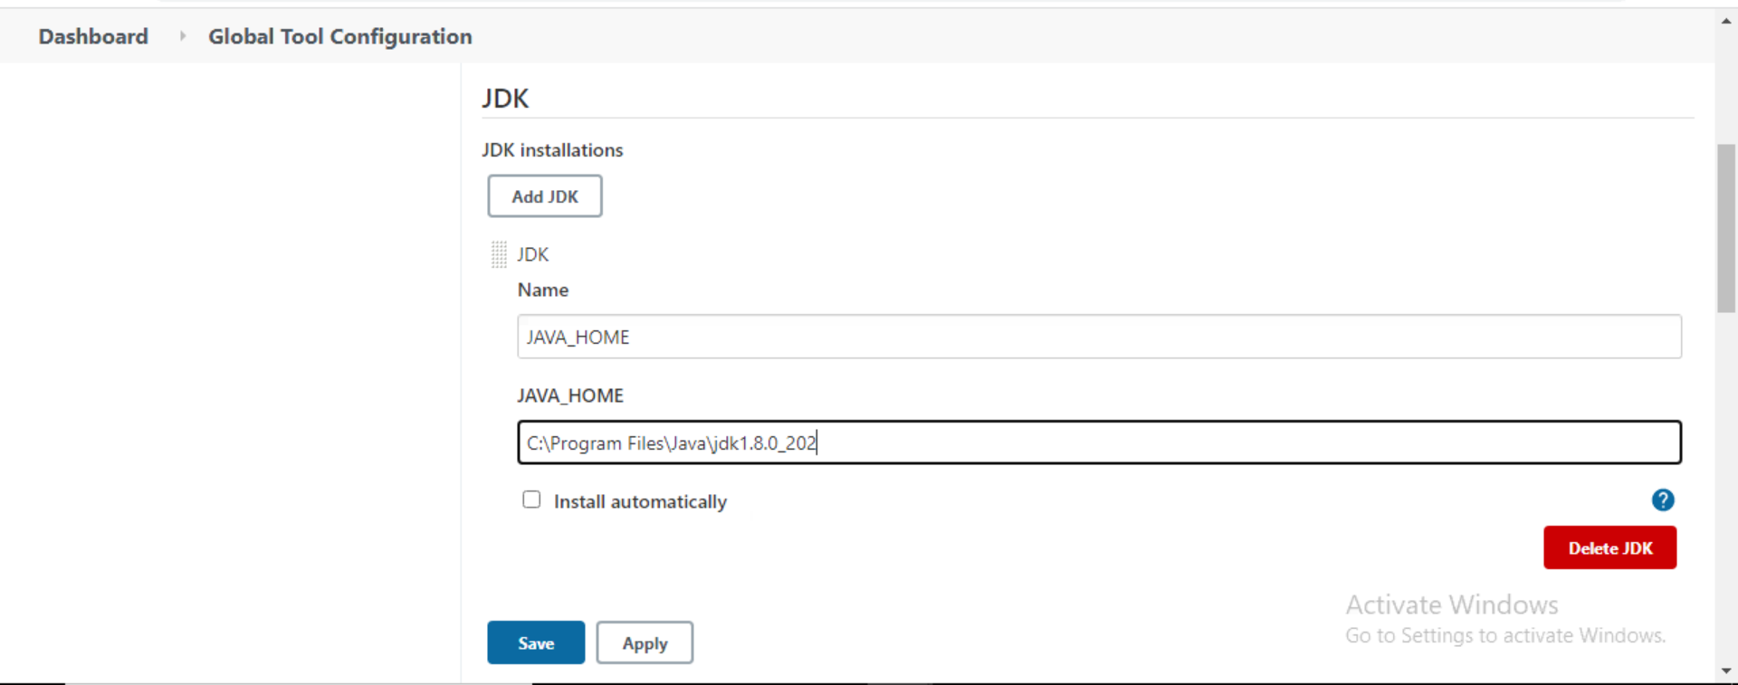

Apply

Go to Maven(Below JDK)

**Add Maven Name(MAVEN_HOME)->Under the specified name(MAVEN_HOME) enter the path of Apache Maven**

If not downloaded

**https://drive.google.com/drive/folders/1RNYWuQ2sFbgf2KsfH_dAk_c2_n-qLE2G?usp=sharing**

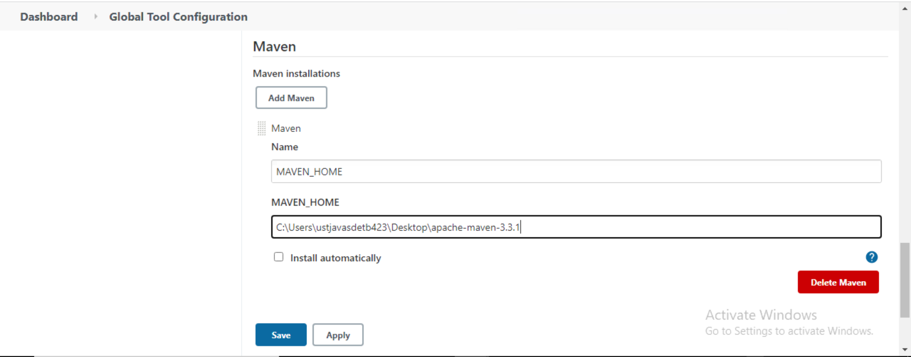

Apply

**Go back to Dashboard->CucumberTest->Configure->**

**Under Build->**

**In Root Pom->Enter the path of the pom file**

**In Goals and Options->clean install(small case)**

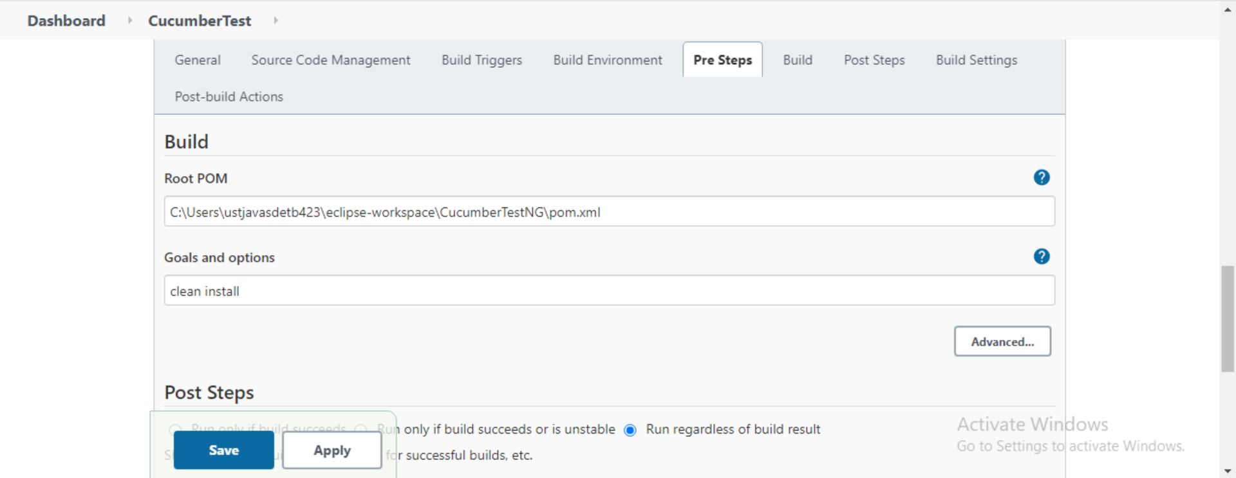

**Go back to Cucumber Test->Build Now->Console Output**

